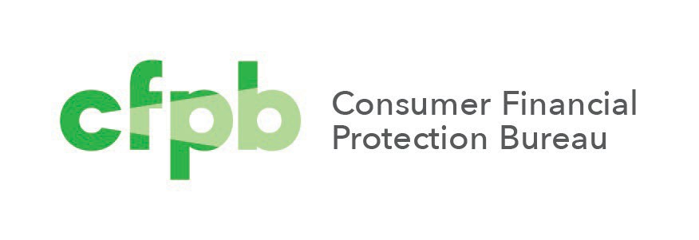

**Zscaler for Consumer Financial Protection Bureau (CFPB)**

Standard Operating Procedure (SOP)

TI-P-00-000

August 2024

Contents

Revision History 4

1. Introduction 1

1.1 Purpose 1

1.2 Scope 1

1.3 Intended Audience 1

1.4 Roles and Responsibilities 2

1.5 Primary Points of Contact 3

1.6 Related Documents 3

2. Inputs and Outputs 4

2.1 Inputs 4

2.2 Outputs 4

3. Receiving Procedure 5

3.1 Initial Receipt of Assets and Equipment 5

3.2 Custodial Property 5

3.3 Creation of Request Ticket 6

3.4 Link All Receiving Documents 6

3.5 Create Assets in the AMDB 7

3.6 Link Assets to the RITM 8

3.7 COR and/or Acquisitions Notification 9

3.8 Internal Controls 10

4. Asset Management Workflows 11

5. Approvals 12

APPENDIX A: KEY TERMS AND ACRONYMS 13

APPENDIX B: GLOSSARY 14

APPENDIX C: CI CLASSES AND MODEL CATEGORIES 16

# **Revision History**

Table 1: Revision History

|  |  |  |  |
| --- | --- | --- | --- |
| **Effective** | **Version** | **Change Summary** | **Point of Contact** |
| 3/19/2019 | 1.0 | Revisions based on ServiceNow changes | E. Lindsey |
| 7/1/2019 | 1.1 | Template updates | A. Adair |
| 5/4/2023 | 1.2 | Revisions based on ServiceNow updates | E. Lindsey |
| 3/13/24 | 1.3 | Proofread and Revised | D. Garcia |

# **Introduction**

## **Purpose**

In accordance with the Consumer Financial Protection Bureau (CFPB) Asset Management (AM) Policy, the Technology and Innovation (T&I) office leverages processes and Standard Operating Procedures (SOPs) to effectively maintain and manage the Bureau’s Information Technology (IT) assets to ensure adequate inventory and accountability controls. This document provides a verifiable and repeatable process when the Bureau receives equipment, hardware assets, or sets of hardware assets from suppliers.

## **Scope**

This SOP applies to Headquarters and Regional Office T&I team members tasked with managing IT assets. This procedure serves as the official document and may be supplemented with user manuals, tutorials, or regular reports.

## **Intended Audience**

AM team members are the primary users of this SOP. The team uses the process outlined in this procedure to perform many of the tasks directly associated with their duties.

## **Roles and Responsibilities**

The table below identifies and describes the roles and responsibilities related to the IT Hardware Receiving document.

Table 2: Roles and Responsibilities Summary

|  |  |
| --- | --- |
| **Role** | **Responsibility** |
| **Facilities Management** | * Notifies AM of shipments arrival. * Coordinates with AM for delivery to designated receiving areas. |
| **Asset Management** | * Receives physical assets and equipment. * Compares received equipment against packing slips. * Creates, updates, and/or completes Request Items (RITM) for incoming orders. * Enters assets into the Asset Management Database (AMDB). * Returns non-conforming products to suppliers per Return Material Authorization (RMA) instructions. * Notifies the Contracting Officer’s Representative (COR) and Procurement of delivery. * Provides monthly reports for entering assets into the AMDB to the CFPB Asset Manager. * Adds new models to the CMDB. |
| **Requestor/COR** | * Determines acceptability of non-conforming products for use. * Obtains Return Merchandize Authorizations (RMAs) from suppliers for non- conforming products. |
| **CMDB Administrator** | * Bulk imports new assets into the CMDB when requested. |
| **Supplier** | * Provides RMA Instructions. * Provides packing slips. * Resolve discrepancies identified by Asset Management or Contracting Officer’s Representative (COR). |
| **CFPB Asset Manager** | * Reviews monthly reports for entering assets into the CMDB. * Reviews Receiving Service Requests (SRs). |
| **T&I Front Office** | * Procures IT hardware assets and equipment. * Notifies CFPB Asset Manager of all procurements |

## **Primary Points of Contact**

The table below identifies Points of Contact (POCs) with knowledge regarding information of the CFPB IT Hardware Receiving SOP process.

Table 3: Document Points of Contact Summary

|  |  |  |
| --- | --- | --- |
| **Role** | **Point of Contact** | **Contact Topics** |
| Document and Process Owner | **Title:** CFPB Federal IT Asset Manager T&I Office: Operations | * Request for document updates * Questions about on the receiving process |

## **Related Documents**

Table 4: Related Documents Summary

|  |  |  |
| --- | --- | --- |
| **Document Name** | **Brief Description** | **Location or Link** |
| Asset Management Policy | Bureau asset management policy | [Asset Management Policy](https://team.cfpb.local/wiki/index.php/Asset_Management_Policy) |
| Directive for Information Technology (IT) Asset Management | T&I IT asset management directive to effectively management IT assets | [Directive for IT Asset Management](https://team.cfpb.local/wiki/index.php/Directive_for_Information_Technology_(IT)_Asset_Management) |

# **Inputs and Outputs**

## **Inputs**

Refer to the table below for inputs to the IT Hardware Receiving SOP Process.

Table 5: Inputs to the Process

|  |  |
| --- | --- |
| **Input** | **Origination** |
| **Packing Slips** | Provided by suppliers |
| **Purchase Orders** | Provided by Purchaser |
| **SR Ticket** | Created by Asset Management |

## **Outputs**

Refer to the table below for outputs to the CFPB IT Hardware Receiving SOP Process.

Table 6: Outputs to the Process

|  |  |
| --- | --- |
| **Output** | **Destination** |
| **Resolved SR Ticket** | AM created and completed the SR ticket in the IT Service Management (ITSM) database |
| **Signed Packing Slips** | AM attaches to the SR ticket and provides information to the COR or PCard holder |

# **Receiving Procedure**

## **Initial Receipt of Assets and Equipment**

The Bureau purchases IT hardware assets and equipment both to replenish stock levels, as well as to stock required items not currently in the Bureau IT environment. The T&I Front Office is the main source for IT purchases and notifies the CFPB Asset Manager when placing an order.

Facilities Management notifies AM of shipments arrival and coordinates delivery to a designated receiving area.

**If a packing slip is provided with the delivery, the AM team completes the following steps:**

1. Compare the received equipment against all packing slips and:
   1. Add a checkmark to each line item that has the correct quantities.
   2. Circle incorrect quantities and indicate the actual quantity received on the slip.
   3. Circle incorrect line items – those items that are received, but not listed on the packing list – and write the description and quantity of what was actually received on the bottom of the packing slip.
2. Sign and date the packing slip.

**If a packing slip is not provided, the AM team completes the following steps:**

1. Identify the purchaser and what items were ordered.
2. Notify the COR or PCard holder to determine whether the order is correct, as well as whether any nonconforming products are acceptable.
3. The COR or PCard holder then works with the supplier to resolve all unaccepted products and quantities.

**Note:** If there are **no** return instructions on the packing slip, the COR *or* PCard holder obtains an RMA from the supplier, and forwards all instructions to AM.

1. AM then ships the products in accordance with the RMA instructions.

## **Custodial Property**

Equipment possessed but not owned by the Bureau should be clearly labeled as the property of the appropriate entity on the device itself, as to ensure the Bureau does not misidentify and tag equipment as CFPB property.

When receiving custodial assets, AM should follow the processes in Sections 3.1-3.3, but should not enter the asset into the AMDB. When generating tickets for these items, the tickets should contain the date received, any receiving documentation, and the group or groups responsible for maintaining the equipment.

## **Creation of Request Ticket**

AM completes all existing tickets or tasks assigned for the order. If a ticket does not exist, AM creates a new RITM in the CMDB in order to track the order. To create a new RITM, open the ServiceNow console.

Complete the following steps:

1. Open the CFPB Service and Support Portal.
2. Select Request IT Services.
3. Select Other under Categories.
4. Select Other Request.

**Note:** Refer to the table below for the fields to update or create the ticket and the corresponding entries.

Table 7: Create Service Request Tickets

|  |  |
| --- | --- |
| **Field** | **Entry** |
| **Short Description** | The entry should be “Receiving <Purchase Order (PO) Number> <Date Received>”. Enter the CFPB PO number on the packing slip or provided by the COR. If the customer PO Number is not listed, use the unique identifier on the packing slip or the order confirmation number provided by the PCard holder. For example, the short description for a shipment received on 10/10/2024, with a PO number of CFPB123, would read “Receiving-CPFB123-10/10/2024.” |
| **Description** | Enter a summary of the assets and equipment, including quantities received and the point of contact. |
| **Attachment** | Attach the receiving documentation before submitting the ticket. |

## **Link All Receiving Documents**

AM scans all completed packing slips and purchase orders, if provided, and attaches to the corresponding task. The naming convention for the packing slip file is “<PO-Order Number-CC Confirmation Number> <Document Type> <Date Received>.” For example, the file name for a packing slip related to a shipment received on 10/10/2024, with a PO number of CFPB123, is “CPFB123-Packing Slip-10/10/2024”. The file name for the purchase order is “CPFB123-Purchase Order-10/10/2024”.

Complete the following steps to link documents:

1. Open the RITM.
2. Click the paperclip icon at the top of the page.
3. In the pop-up box, click Choose Files.
4. Click the file to attach to the ticket and click Open (this automatically attaches the file to the ticket).
5. Click the X to close the pop-up box.

**Note:** AM provides an electronic copy of all attached documentation to the COR or PCard holder.

## **Create Assets in the AMDB**

If the shipment contains less than 25 items, AM asset tags and enters all new tracked IT hardware assets into the AMDB.

**Note:** Custodial Assets, those IT items which the Bureau possesses, but which it did not purchase, must **not be entered** into the AMDB, as they are not owned by CFPB. For additional information about Custodial Assets, review Section 3.8.

Complete the following steps to create a new asset in the CMDB:

1. Click **Asset** in the Application Navigator.
2. Click on **Hardware Assets**.
3. Click the **New** button at the top of the page.
4. Click the magnifying glass to select the correct **Model category**.
5. Click the magnifying glass to select the correct **Model**.
6. Continue to fill in the fields indicated in **the table below**.

Refer to **Appendix C** for a list of the most common CI classes and model categories.

**Note:** If the model does not exist, AM creates the new model in the AMDB. The table below indicates what fields to update to create a new asset and the corresponding values to enter. Required fields are indicated with an asterisk **(*)**.

For shipments with *25 or fewer* assets requiring tracking, AM enters all tracked assets into the CMDB within 24 hours of receipt. For quantities greater than 25, or when there is no model in the CMDB, AM enters all assets into the CMDB within five business days.

Table 8: Creating Assets

|  |  |  |
| --- | --- | --- |
| **Field** | **Tab** | **Entry** |
| **Model Category\*** | Main Page | Use the search to select the correct model category from the list. |
| **Model\*** | Main Page | Use the search to select the correct model from the list. |
| **Asset Tag** | General | Affix a barcode to the asset and enter the Asset tag number. |
| **Field** | **Tab** | **Entry** |
| **Serial Number** | General | Enter the asset Serial Number. |
| **Location** | General | Use the search function to select the correct Location. |
| **Floor** | General | Enter the correct Floor. |
| **Room** | General | Enter the correct Room. |
| **Stockroom** | General | Enter the correct Stockroom. |
| **State** | General | Enter “In Use” if the delivery is going immediately to a specific individual; otherwise, enter “In Stock.” |
| **Substate** | General | Enter “Reserved” if the delivery is for a specific individual; otherwise, enter “Available.” |
| **Assigned to** | General | Enter the recipient’s name if the delivery is going immediately to a specific individual. Otherwise, leave this blank until deployed from stock. |
| **Order Received** | Financial | Use the calendar icon and select the date of order receipt. |
| **PO Number** | Financial | Enter the purchase order number or “PCard” for anything not purchased via a PO. |
| **Cost** | Financial | Enter the price per item. |
| **Expenditure Type** | Financial | Enter Opex (operational) or Capex (capitalized). |

**Note:** AM submits a ticket with a spreadsheet containing all pertinent information to the ServiceNow Administrators to bulk import the assets into the system, for deliveries with more than 25 tracked assets.

## **Link Assets to the RITM**

AM links all acquired tracked assets to the corresponding RITM. Complete the following steps to link assets:

1. Open the **RITM**.
2. Scroll to **Related Links** at the bottom of the page.
3. Click the **Affected CIs** tab.
4. Click **Edit**.
5. Enter the **Configuration Item** name in the search field under Collection.
6. Hit **Enter** to **Search**.
7. Click the CI you want to link and click the **right arrow** to add it to the **Affected CIs list**.
8. Click **Save**.

## **COR and/or Acquisitions Notification**

AM notifies the CFPB Federal Asset Manager, COR/Requestor, and Procurement via email upon receipt of all line items and attaches the email to the SR. AM then updates the receiving task to Closed complete to indicate full receipt of the delivery.

## **Internal Controls**

AM implements the following internal controls in order to ensure compliance with this SOP.

#### **Report on Time to Enter Assets**

AM provides a monthly report to the CFPB Asset Manager indicating the number of days taken for assets entered into the AMDB. This report must include a note all asset records not meeting the requirements provided in section 3.4.

#### **Review of Receiving Service Requests**

The CFPB Asset Manager reviews receiving RITMs for accuracy and completeness monthly.

* + - * If AM has 10 or fewer tickets in a given month, the Asset Manager reviews all tickets.
      * If AM has between 10 and 100 tickets, the Asset Manager conducts a random sample of 25 percent of the tickets, reviewing a minimum of 10 tickets.
      * If AM has more than 100 tickets, the Asset Manager conducts a random sample of 15 percent of tickets, reviewing a maximum of 25 tickets.

#### **Control Activity Summary**

AM implements the following internal controls to ensure compliance with this SOP.

Table 9: Control Activities Summary

|  |  |  |  |
| --- | --- | --- | --- |
| **Control Activity** | **Responsibility** | **Timing** | **Key Output(s)** |
| **Report on Time to Enter Assets** | IT Hardware Asset Manager | Monthly | Report on the time to enter assets in the AMDB if applicable.  Listing of all SRs for any IT equipment received. |
| **Review of Receiving SR** | CFPB IT Asset Manager | Monthly | Monthly feedback to the IT Hardware Asset Manager on performance against the SOP. |

# **Asset Management Workflows**

The figure below displays the cross-functional (i.e., “swim lane”) workflows of the following SD AM processes.

Figure 1: IT Asset Hardware Receiving

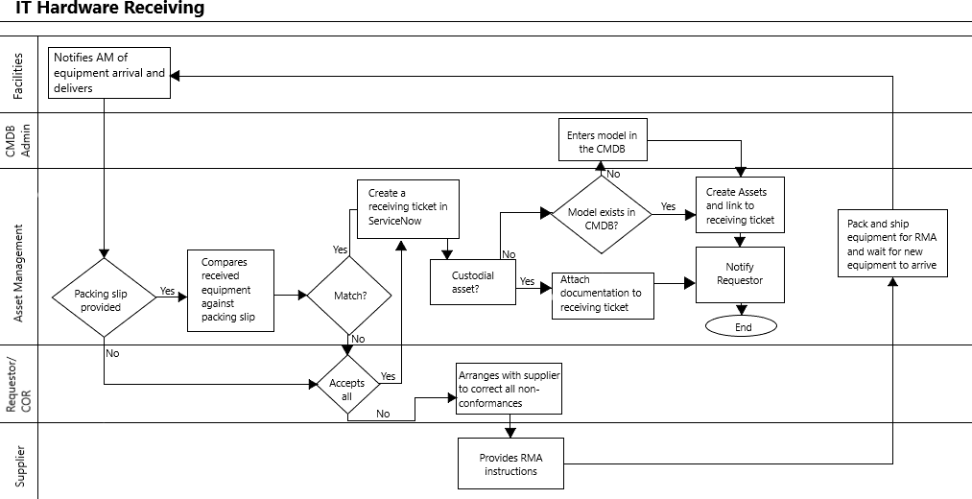

# **Approvals**

| ***Document Approval*** | | | |
| --- | --- | --- | --- |
| ***To be signed by the Infrastructure Operations Lead*** | | | |
| *This process is approved for use and immediate implementation.* | | | |
|  | | | |
|  | Signature and Date |  |  |
| ***To be signed by the Policy Compliance and Asset Management Program Manager*** | | | |
| *This process is approved for use and immediate implementation.* | | | |
|  | | | |
|  | Signature and Date |  |  |

# **APPENDIX A: KEY TERMS AND ACRONYMS**

Table 10: Key Terms and Acronyms

|  |  |
| --- | --- |
| **Term/Acronym** | **Definition** |
| **AM** | Asset Management |
| **AMDB** | Asset Management Database |
| **APM** | Asset Program Manager |
| **AR** | Asset Record |
| **CFPB** | Consumer Financial Protection Bureau |
| **CI** | Configuration Item |
| **CMDB** | Configuration Management Database |
| **COR** | Contracting Officer’s Representative |
| **IT** | Information Technology |
| **ITIL** | Information Technology Infrastructure Library |
| **ITSM** | IT Service Management |
| **PO** | Purchase Order |
| **POC** | Point of Contact |
| **RITM** | Request Item |
| **RMA** | Return Merchandise Authorization |
| **SD** | Service Desk |
| **SOP** | Standard Operating Procedure(s) |
| **SR** | Service Request |
| **T&I** | Technology and Innovation |

# **APPENDIX B: GLOSSARY**

The table below provides a list of the defined terms relevant to this SOP.

Table 11: Glossary of Terms

|  |  |
| --- | --- |
| **Term/Acronym** | **Definition** |
| **Asset** | Asset refers to any CFPB-owned hardware item used for the purpose of conducting CFPB business. |
| **AM** | AM is a systematic process of deploying, operating, maintaining, upgrading, and disposing of assets in the most cost-effective manner possible. The term refers to the process of monitoring and maintaining facilities and systems, with the objective of providing the best possible service to users. AM includes the practice of managing assets to achieve the greatest return on investment in facilities, personnel, and systems. |
| **Asset Tag** | At CFPB, asset tags refer to barcode stickers attached to both fixed and portable IT assets for useful life identification and inventory control tagging purposes (refer to the Barcode entry below). |
| **Barcode** | A barcode is an arrangement of alternating bars and spaces printed onto an asset tag to identify items and enable automatic interpretation by optical scanners to avoid manual input (also known as automatic recognition). Barcodes enable optical digital scanning of alphabetic and numeric characters and symbols into a spreadsheet or database (refer to Asset Tag entry above.) |
| **CFPB** | The CFPB is an independent agency of the United States (U.S.) government responsible for consumer protection in the financial sector. Its jurisdiction includes banks, credit unions, securities firms, payday lenders, mortgage- servicing operations, foreclosure relief services, debt collectors, other financial companies operating in the U.S. The CFPB’s creation was authorized by the Dodd-Frank Wall Street Reform and Consumer Protection Act, whose passage in 2010 was a legislative response to the financial crisis of September 2008 and the resulting economic recession in the United States. |
| **COR** | A CORs representative is an individual designated in accordance with Defense Federal Acquisition Regulation Supplement (DFARS) subsection 201.602-2 and authorized in writing by the contracting officer to perform specific technical or administrative functions.  If the Contracting Officer designates a COR, the Contractor receives a copy of the written designation. It specifies the extent of the COR’s authority to act on behalf of the contracting officer. The COR is *not* authorized to make any commitments or changes that affects price, quality, quantity, delivery, or any other term or condition of the contract. (Source: DFARS 252.2). |

|  |  |
| --- | --- |
| **Term/Acronym** | **Definition** |
| **Cross-Functional Flowchart** | A cross-functional flowchart (sometimes referred to as a “swim lane diagram”) is a business process mapping tool used to graphically illustrate the steps and stakeholders involved in a given process workflow. Cross-functional flowcharts consist of a sequence of activity steps and the interactions between the individuals/groups involved in the process. Each participant in the process is displayed in a horizontally- or vertically displayed column (or “swim lane”). The associated tasks/activities involved in the process are articulated in sequence in the “swim lane” corresponding to that stakeholder. |
| **Inventory** | Inventory refers to recording and tracking the goods and materials that a business holds for the ultimate purpose of conducting its business. Inventory management involves leveraging the percentage of stocked goods against deployed goods while factoring in the depletion rate of those goods.  The scope of inventory management concerns the fine lines between replenishment lead time, AM, inventory forecasting, future inventory price forecasting, and physical inventory, available physical space for inventory, replenishment, returns/defective goods, and demand forecasting. |
| **Procedure** | A procedure refers to a sequence of steps intended to be followed in a specific defined order to solve a problem, accomplish a task, and/or produce a consistent desired outcome. |
| **SD** | A CFPB SD provides customers and users with an informed single POC for all IT requirements. In addition to actively monitoring and owning incidents and user questions/requests, the SD provides the communications channel for other service management disciplines within the CFPB user community. The SD also provides an interface for other IT-related activities such as customer CR, third parties (e.g., maintenance contracts), and software licensing. |
| **SOP** | SOPs are a set of step-by-step instructions used to achieve a desirable, predictable and standardized result often within the context of a more involved overall process. In the context of the CFPB SD, these procedures are used to implement a consistent and reusable body of knowledge for handling customer issues and user SR. An SOP may refer to a *document type* in which such procedures are collected, updated and maintained. |
| **ServiceNow** | ServiceNow is the cloud-based Service Management product of ServiceNow, Inc. ServiceNow is built on the ServiceNow platform and it supports all major ITIL processes. SRs are entered via internet, email, and mobile devices. Use the personalized management portal for the information and views that are needed for work. |

# **APPENDIX C: CI CLASSES AND MODEL CATEGORIES**

The table below provides a list of common Hardware model categories for assets in the AMDB.

Table 12: CI Classes and Subclasses

|  |  |
| --- | --- |
| **Class** | **Model Category** |
| **Hardware** | AV Hardware |
| Computer |
| Firewall Hardware |
| Hardware |
| Intrusion Detection System |
| IP Phone |
| IP Router |
| IP Switch |
| Network Appliance Hardware |
| Printer |
| Server |
| Smartphone |
| Storage Device |
| Storage Server |
| Tablet |
| UPS |
| Windows Server |
| Wireless Access Point |